**Teachers Retention rate Analysis(2016-2021)**

Using Cohort analysishorizontal line

# Placeholder image

# Introduction

The primary objective of this project was to analyze teacher retention rates using cohort analysis, focusing on teachers who started their employment between the years 2016 and 2021. The goal was to identify trends in retention and understand the dynamics of teacher attrition over this period. By conducting a cohort analysis, we aimed to uncover patterns and insights that could inform strategies to improve teacher retention.

### 

# Data Collection:

* Data was collected from the school's HR system, which included information on teacher details in each year , demographic details, and job roles.
* The dataset was filtered to include only teachers hired between 2016 and 2021 and there is no data available for 2019.

# Cohort Definition:

* Each cohort was defined by the year of hire. For example, the 2016 cohort includes all teachers hired in 2016, the 2017 cohort includes all teachers hired in 2017, and so on.

# Retention Metrics:

* Retention rate was calculated as the percentage of teachers remaining employed at the school at the end of each year following their hire.
* Churn rate was calculated as the percentage of teachers who left the school within each year following their hire.

# Analysis Tools:

* Python and its libraries (Pandas, NumPy, Matplotlib and seaborn) were used for data cleaning, processing, and visualization.
* Cohort analysis was performed by creating retention matrices and visualizing retention rates across different cohorts.

# Findings

1. **Overall Retention Trends:**
   * There was a noticeable decline in retention rates across cohorts from 2016 to 2021. The earlier cohorts (2016) exhibited higher retention rates compared to later cohorts (2017,2018, 2020).
2. **Yearly Retention Analysis:**
   * The first-year retention rate was relatively high for 2016-17 cohorts, with an retention rate of approximately 73%.
   * The maximum churn occurred in the second year for all cohorts.

3. **Cohort-Specific Insights:**

* + The retention rate is approximately 60% of teachers remaining after five years across all cohorts.
  + The 2018 cohort showed a moderate increase, with around 69% retention after three years.
  + The 2020 cohorts exhibited a steeper decline, with only about 21% retention after one year.

# Visualization

#### **Retention Rate by Cohort Year**

A heatmap was plotted to visualize the retention rates for each cohort over the observed years. Each block represents a cohort, starting at 100% in the year of hire and showing the decline in retention over subsequent years.

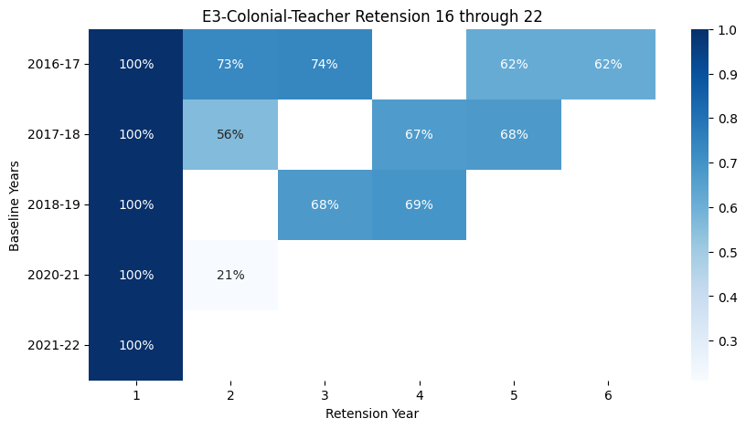

### 

# 

# Conclusion

The cohort analysis revealed critical insights into the retention patterns of teachers hired between 2016 and 2021. Key findings include:

* A general decline in retention rates for more recent cohorts.
* The highest attrition occurred in the second year of employment across all cohorts.

### 

### 

### 

### Recommendations

To address the declining retention rates and high second-year churn, the following strategies are recommended:

* **Enhanced Support Programs:** Implement targeted support programs for new teachers, especially in their second year, to address common challenges and improve job satisfaction.
* **Mentorship Initiatives:** Establish mentorship programs pairing new teachers with experienced ones to provide guidance and support.
* **Professional Development:** Invest in ongoing professional development opportunities to keep teachers engaged and motivated.
* **Feedback Mechanisms:** Regularly collect and act on feedback from teachers to understand their concerns and improve their work environment.

### Future Work

Further analysis could be conducted to understand the factors contributing to the observed trends. This might include examining demographic variables, job roles, and external factors such as policy changes or economic conditions.

By addressing the identified challenges and implementing the recommended strategies, the school can improve teacher retention rates and ensure a more stable and experienced teaching workforce.